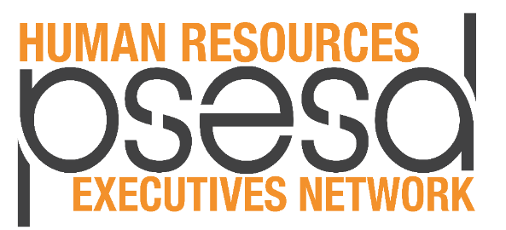
Agenda
Meeting Facilitator: Tim Collins, Seattle Public Schools

October 22, 2019  9:00 a.m. – 12:00 p.m.  Green River College  Kent Station  Or  Zoom Videoconference  Join from PC, Mac, Linux,  iOS, or Android  https://zoom.us/j/971879329  Or join via telephone  (646) 558-8656  Meeting ID: 971 879 329  Virtual waiting room will open at 8:45 a.m. to connect in order to troubleshoot potential audio/visual issues | - 9:00 – Welcome & Networking  - 9:30 – Paraeducator Fundamental Course of Study  Greta Bornemann & Erin Stewart  - 10:15 – Regional Superintendent Priorities and  HR Executive Network Support  Tim Collins, Seattle Public Schools  - 10:30 – Break  - 10:45 – Professional Conduct Compliance  Catherine Slagle, OSPI & David Kinnunen, OSPI  - 12:00 – Adjournment

Our Upcoming Meetings
Tuesday, January 7, 2020, Puget Sound ESD
Tuesday, May 5, 2020, Puget Sound ESD
9:00 a.m. – 12:00 p.m.
For all agendas, handouts, and presentations from HR Executives Network meetings, please visit the HR Executives Network page on the newly redesigned and ADA compliant www.psesd.org:
- Hover over “Partner Sites” at the very top (teal menu bar), and click on “District Executives” from the drop down menu
- Click on “Human Resource Executives Network” on the top menu bar (a password is no longer necessary)

